**JOHN WESLEY SCHOOL ESHOWE**

**SPECIAL LOCKDOWN NEWSLETTER 10**

**Tuesday 28 July 2020**

Dear Parents

**“*Knowing God leads to self-control. Self-control leads to patient endurance, and patient endurance leads to godliness.”*  2 Peter 1:6**

**POSITIVE CASES**

* The boy in Grade 6 who tested positive is doing well. The Grade 6 class remains in quarantine.
* On Saturday, our Grade 7 teacher reported that she has tested positive. (She went for private testing, as DoH results for our four teachers who tested last Monday, have not returned yet.) She has not been in class for a week. Therefore, we closed the Grade 5 and 7 classes immediately and put those four teachers into quarantine (Ms Khumalo, Mr Wagenaar, Ms Hutton, Ms Beukes.)

**CLOSING OF SCHOOL**

Following the lead of the government after the President’s address last Thursday night, we are closing school as follows:

* Our school will close this Wednesday 29 July
* Workpack 1 (for 2 weeks) will be sent home with children on Wednesday.
* Grade 7 will return to school on Tuesday 11 August.
* Workpack 2 for Grades R to 6 will be collected on Tues 11 and Wed 12 August.
* All other grades will return to school on Monday 24 August.
* Please ensure that your child’s teacher has your cell number.
* Please keep to all protocols while your child is at home.

**WORKPACK COLLECTION**

* If your child is not at school this Wednesday 29 July, please collect a workpack on Wednesday afternoon from 14:30 to 16:00 or on Thursday morning from 08:30 to 14:30.
* Second workpack collections will be at the following dates and times:
  + Gr R to 3 on **Tuesday 11 August**
    - Gr R – 08:30 to 10:00
    - Gr 1 – 10:00 to 11:30
    - Gr 2 – 11:30 to 13:00
    - Gr 3 – 13:00 to 14:30
  + Gr 4 to 6 on **Wednesday 12 August**
    - Gr 4 – 08:30 to 10:00
    - Gr 5 – 10:00 to 11:30
    - Gr 6 – 11:30 to 13:00
* The school office will be open every day during lockdown between 08:00 and 14:30.

**FINANCES**

Thank you to those who have paid fees, however, a number of parents are still behind in payments. If you have lost your job or salary because of COVID 19, **please collect an application from the office to inform us**.

**MERIT CERTIFICATES**

The following children have gained their **YELLOW** CERTIFICATES (150 merit points) since last week. CONGRATULATIONS TO:

Gr 1 **Ongeziwe Nkosi Tumelo Ngema Andiswa Cele**

Gr 3 **Aphiwe Luthuli Olwethu Ndabankulu Elisha Shezi Olwethu Msomi**

Gr 4 **Anele Majola**

Gr 6 **Sbonga Mseleku**

The following have gained their **RED** CERTIFICATES (300 merit points)

Gr 2 **Okuhle Mtolo Remofiloe Tlali**

Gr 7 **Nhlalo Khuzwayo**

The following have gained their GREEN CERTIFICATES (450 merit points)

Gr 2 **Simthandile Mhlongo**

Gr 7 **Lusanda Magwaza**

**SPORT**

We ran the SACSSA VIRTUAL CROSS-COUNTRY on Saturday 25 July at the same time as other SACSSA schools. SACSSA returned overall results yesterday. Well done to the following athletes!

9 GIRLS **Mpilenhle Xulu** (pic) 2nd 9 BOYS **Luvuyo Sibiya** (pic) 1st

**Michelle Fuwe** 4th **Anele Majola** 2nd

**Wanda Radebe** 4th

11 GIRLS **Nelisa Fakude** (pic) 3rd 10 BOYS **Sambulo Mbuyazi** 1st

12 GIRLS **Aphelele Khathi** 1st 11 BOYS **Takunda Maseko** 4th

**Ntuthuko Mkhwanazi**5th

12 BOYS **Munei Majola** 1st

The next two events are on Sat 8 August (**cellphones needed**) and Sat 22 August (**NO** cellphones needed). Cross-country athletes will meet at school at the same time (08:00) and return by 10:00.

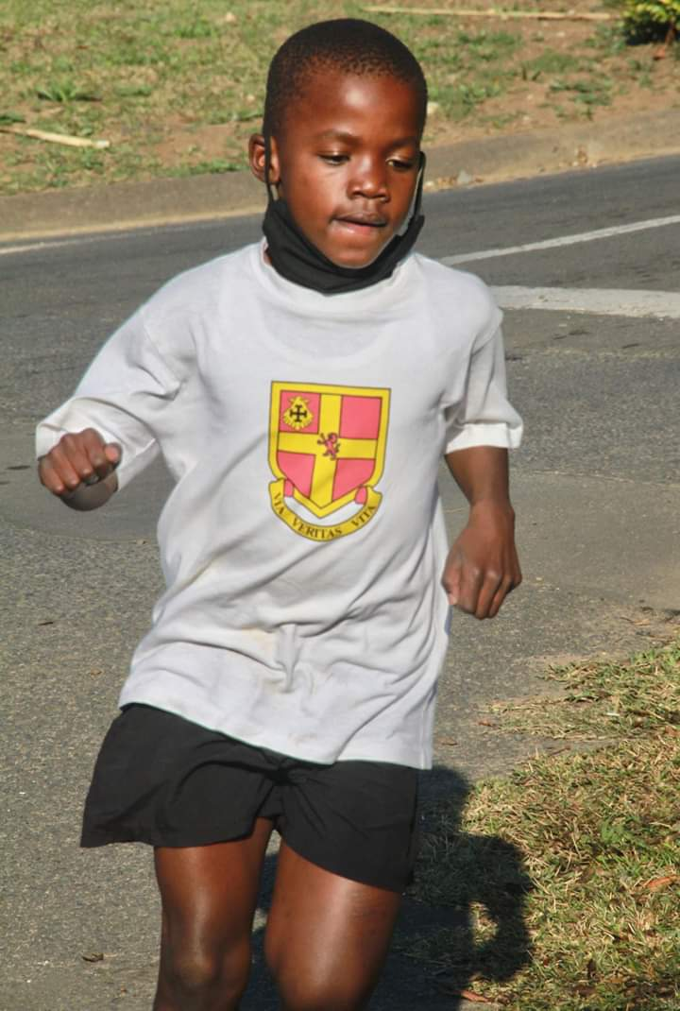 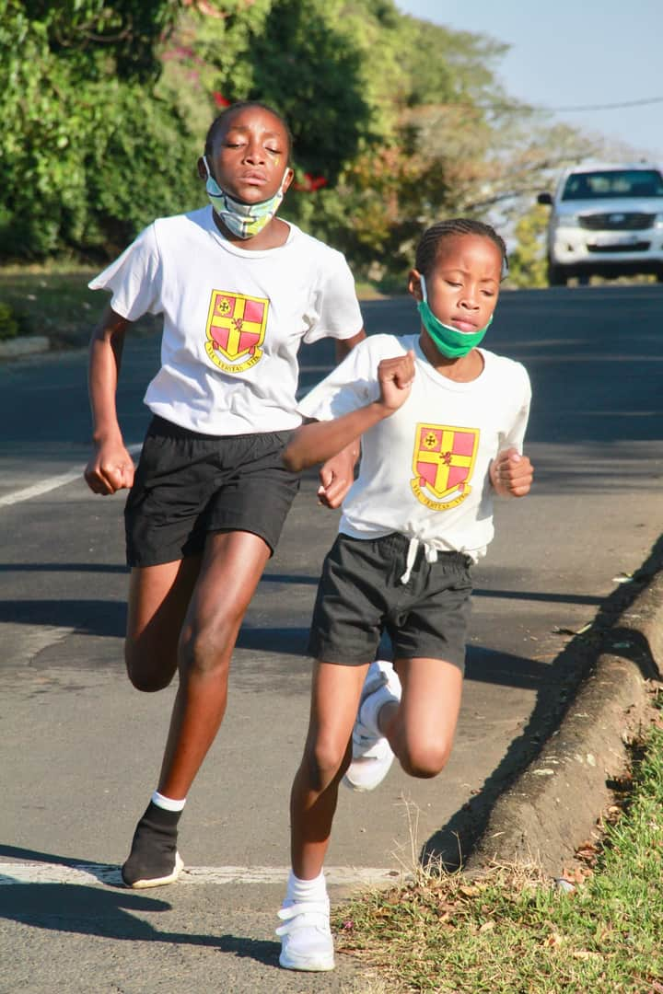

***Stay safe!*** School contact details: 035 474 2516

In the service of our children If the TELKOM line is not working please use 074 808 0698

**Mr A.M. Stuart** School website<https://jwseshowe.co.za/>

PRINCIPAL **JOHN WESLEY SCHOOL FNB Account No 5219 1085 079**

**…………………………………………………………………………………………………………………………………………………………………**

**JOHN WESLEY SCHOOL ESHOWE NEWSLETTER Tuesday 28 July 2020 REPLY SLIP**

I, the parent of _____________________________________________________in Grade ______

have received and read the newsletter for Tuesday 28 July 2020.

Signed: ___________________________________Date: ________________________________________

Cell number/s:__________________________________________________________________________