**JOHN WESLEY SCHOOL ESHOWE**

**SPECIAL LOCKDOWN NEWSLETTER 7**

**Tuesday 7 July 2020**

Dear Parents

**“*In matters of style, swim with the current; in matters of principle stand like a rock.”*  Thomas Jefferson**

**GRADE 1 TEACHER**

Our Grade 1 teacher, **Ms Kate Basson**, is leaving us on Friday 17 July. Her husband has a job in the KZN Midlands. We thank Ms Basson for the dedication and effort she has put into her work in the classroom, on the athletics track, in the swimming pool and with the Wildlife Club. We will miss you Ms Basson! Replacing her, on 3 August, is **Ms Felicia Meyer**, who is currently teaching at Gratton. To fill the gap of two weeks until Ms Meyer joins us, we will have Ms Trevlyn Palframan assisting Ms Waiswa in the Grade 1 classes.

**GRADE 5**

The Grade 5 class will return next Mon 13 July. Masks must be worn. They will start at 07:30 and end at 14:30. Ms Beukes will be waiting to do screening. The Grade 5 class will be in the hall for lessons.

**UNIFORM**

The UNIFORM SHOP will be open every Friday from 07:30 to 13:30 and will be controlled by Ms Henderson. Please can all uniform be bought during these times.

**AFTERCARE**

Please note that there will be no aftercare offered by Ms Waiswa until further notice.

**COUNSELLING**

If any person needs counselling during this unsettled time, there are a number of people trained to assist us (some of the following people do charge a fee)

* Rev Sakhi Ciliza (Minister at Eshowe Methodist) 078 508 0860 [edmundciliza@gmail.com](mailto:edmundciliza@gmail.com)
* Ms Corli Viljoen (Registered counsellor) 078 385 8903 [renewft.1@gmail.com](mailto:renewft.1@gmail.com)
* Ms Robin Wagenaar (Psychologist in training) 081 565 0564 [robinwagenaar@hotmail.com](mailto:robinwagenaar@hotmail.com)
* Ms Mandisa Majola (Psychologist – rooms near Steers) 067 145 3743 [ndikamajola@gmail.com](mailto:ndikamajola@gmail.com)
* Ms Shelley Hall (Psychologist at Dr Brits rooms) 063 055 2172 [shelleykimhall@icloud.com](mailto:shelleykimhall@icloud.com)

**FINANCES**

Thank you to those who have paid fees, however, a number of parents are still behind in payments. If you have lost your job or salary because of COVID 19, **please collect an application from the office to inform us**.

**COVID 19 EMERGENCY NUMBERS FOR THE DEPARTMENT OF HEALTH**

0800 029 999 or 0800 111 132 or WhatsApp 060 012 3456

Healthcheck: *134*832# (free) Government website [www.sacoronavirus.co.za](http://www.sacoronavirus.co.za)

Doctors on call helpline: 087 055 0234 (8 to 5)

**SCHOOL WEBSITE**

Special thanks to Miss Beukes who has built a new website for our school. The link is: <https://jwseshowe.co.za/>

Please have a look – the website also contains newsletters.

**MERIT CERTIFICATES**

The following children have gained their **YELLOW** CERTIFICATES (150 merit points) since last week. CONGRATULATIONS TO:

Grade 2 **Sibulelo Sibiya**

The following have gained their **RED** CERTIFICATES (300 merit points)

Grade 2 **Lwandile Shezi**

**Emihle Sigwaza**

**Siqalo Tembe**

Grade 7 **Nothando Khoza**

**Lusanda Magwaza**

**Munei Majola**

**Minenhle (Lungelo) Mtetwa**

**SPORT**

KZN Christian Schools is offering a VIRTUAL CROSS-COUNTRY event to be held on Saturday 11 July. Children who have downloaded a fitness APP to their cellphone, and have downloaded data, may run. The recommended APP is STRAVA, found on the website – strava.com. We will meet at school at 08:00 in school sports kit. Only athletes who have returned the KZNCSSA CROSS-COUNTRY FORM by tomorrow (Wed 8 July) will run. Athletes must bring their **own** water and food. We will run in the backstreets of Eshowe (Hulett, Dickens, Pennefather) We will return to school by 11:30.

**WAITING FOR ALL OUR LEARNERS**

Samphiwa carrying chairs to the hall. The Grade 4 class on their first day back.

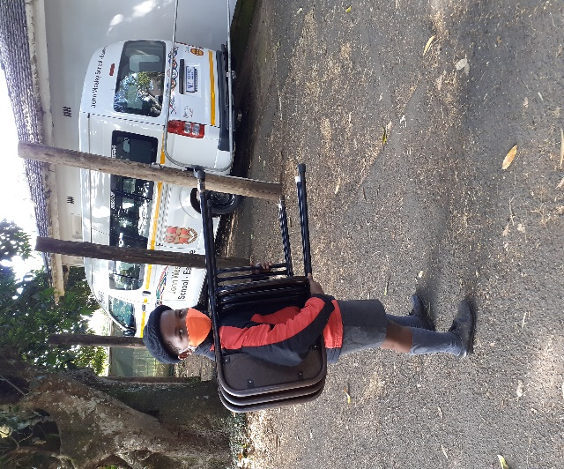 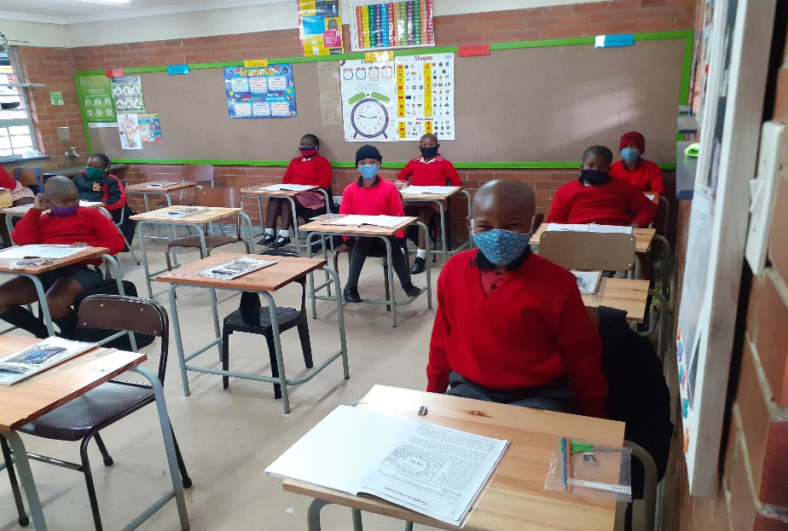

***Stay safe!*** School contact details: 035 474 2516

In the service of our children If the TELKOM line is not working please use 074 808 0698

**Mr A.M. Stuart JOHN WESLEY SCHOOL**

PRINCIPAL **FNB Account No 5219 1085 079**

**…………………………………………………………………………………………………………………………………………………………………**

**JOHN WESLEY SCHOOL ESHOWE NEWSLETTER Tuesday 7 July 2020 REPLY SLIP**

I, the parent of __________________________________________________________________________ in Grade ______

have received and read the newsletter for Tuesday 7 July 2020.

Signed: __________________________________________________Date: ________________________________________

Cell number/s:_________________________________________________________________________________________