**JOHN WESLEY SCHOOL ESHOWE**

**SPECIAL LOCKDOWN NEWSLETTER 6**

**Monday 29 & Tuesday 30 June 2020**

Dear Parents

**“*A soft answer turns away wrath, but a harsh word stirs up anger.”*  Proverbs 15:1**

**GRADE 1; 2; 3; 6 & 7**

The Gr 1; 2; 3; 6 & 7 classes are back. We welcome the Gr 3 class back to their first week after lockdown.

**GRADE R & 4**

The Grade R and 4 classes will return next Mon 6 July. Masks must be worn. The Grade 4 will start at 07:15 and end at 14:15. Mrs de Waal will be waiting to screen them before they enter the classroom. The Grade R class will start at 7:30 and end at 12:45. Mrs Engelbrecht and Mrs Mathonsi will be waiting to screen them. Grade R will be split between the Grade R classroom and the manse for lessons.

**UNIFORM**

The UNIFORM SHOP will be open every Friday from 07:30 to 13:30 and will be controlled by Mrs Henderson. Please can all uniform be bought during those times. School beanies (black) are available for R50. Beanies must only be black; no different coloured beanies must be worn.

**RETURN OF OTHER CLASSES**

The Department of Education has approved our dates of return as follows:

GRADE 4 Monday 6 July: times 7:15 to 14:15 (Friday close at 12:15)

GRADE R “ “ “ : times 7:30 to 12:45 (Friday close at 12:30)

GRADE 5 Monday 13 July: times 7:30 to 14:30 (Friday close at 12:30)

**AFTERCARE**

Please note that there will be no aftercare offered by Ms Waiswa until further notice.

**COUNSELLING**

If any person needs counselling during this unsettled time, there are a number of people trained to assist us (some of the following people do charge a fee)

* Rev Sakhi Ciliza (Minister at Eshowe Methodist) 078 508 0860 [edmundciliza@gmail.com](mailto:edmundciliza@gmail.com)
* Ms Corli Viljoen (Registered counsellor) 078 385 8903 [renewft.1@gmail.com](mailto:renewft.1@gmail.com)
* Ms Robin Wagenaar (Psychologist in training) 081 565 0564 [robinwagenaar@hotmail.com](mailto:robinwagenaar@hotmail.com)
* Ms Mandisa Majola (Psychologist – rooms near Steers) 067 145 3743 [ndikamajola@gmail.com](mailto:ndikamajola@gmail.com)
* Ms Shelley Hall (Psychologist at Dr Brits rooms) 063 055 2172 [shelleykimhall@icloud.com](mailto:shelleykimhall@icloud.com)

**FINANCES**

Thank you to those who have paid fees, however, a number of parents are still behind in payments. If you have lost your job or salary because of COVID 19, **please collect an application from the office to inform us**.

**COVID 19 EMERGENCY NUMBERS FOR THE DEPARTMENT OF HEALTH**

0800 029 999 or 0800 111 132 or WhatsApp 060 012 3456

Healthcheck: *134*832# (free) Government website [www.sacoronavirus.co.za](http://www.sacoronavirus.co.za)

Doctors on call helpline: 087 055 0234 (8 to 5)

**SCHOOL WEBSITE**

Special thanks to Miss Beukes who has built a new website for our school. The link is: <https://jwseshowe.co.za/>

Please have a look – the website also contains newsletters.

**MERIT CERTIFICATES**

The following children have gained their **YELLOW** CERTIFICATES (150 merit points) since last week. CONGRATULATIONS TO:

Grade 1 **Nkosis’phile Mthembu**

Grade 2 **Junior Mdlalose**

**Amahle Somakahle**

Grade 5 **Thando Ciliza**

**Motheo Nxumalo**

The following have gained their **RED** CERTIFICATES (300 merit points)

Grade 2 **Simthandile Mhlongo**

Grade 7 **Londeka Ngcobo**

**Xander Thwala**

**SPORT**

KZN Christian Schools is offering a VIRTUAL CROSS-COUNTRY event to be held on Saturday 11 July. Children who have downloaded a fitness APP to their cellphone may run. We will set out a course and athletes will use their APP to record their run. A Screenshot of the result must be sent to KZN and they will announce the medals. We will give more details in a separate notice.

**WAITING FOR ALL OUR LEARNERS**

The Grade 2 class learning about COVID 19 from Mr Stuart at the information wall.

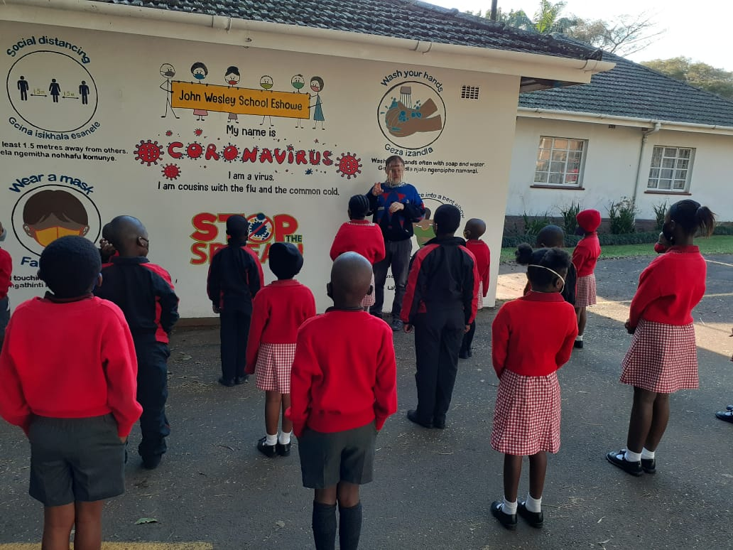

***Stay safe!*** School contact details: 035 474 2516

In the service of our children If the TELKOM line is not working please use 074 808 0698

**Mr A.M. Stuart JOHN WESLEY SCHOOL**

PRINCIPAL **FNB Account No 5219 1085 079**