**JOHN WESLEY SCHOOL ESHOWE**

**SPECIAL LOCKDOWN NEWSLETTER 8**

**Tuesday 14 July 2020**

Dear Parents

**“*My grace is sufficient for you, for My power is made perfect in weakness.”*  2 Corinthians 12:9**

**GRADE 1 TEACHER**

Our Grade 1 teacher, **Ms Kate Basson**, leaves us this Friday 17 July. Her husband has a job in the KZN Midlands. We thank Ms Basson for the dedication and effort she has put into her work in the classroom, on the athletics track, in the swimming pool and with the Wildlife Club. We will miss you Ms Basson! Replacing her, on 3 August, is **Ms Felicia Meyer**, who is currently teaching at Gratton. To fill the gap of two weeks until Ms Meyer joins us, we will have Ms Trevlyn Palframan assisting Ms Waiswa in the Grade 1 classes.

**GRADE 5**

The Grade 5 class has returned. We now have all our grades back at school.

**UNIFORM**

The UNIFORM SHOP will be open every Friday from 07:30 to 13:30 and will be controlled by Ms Henderson. Please can all uniform be bought during these times.

**AFTERCARE**

Please note that there will be no aftercare offered by Ms Waiswa until further notice.

**COUNSELLING**

If any person needs counselling during this unsettled time, there are a number of people trained to assist us (some of the following people do charge a fee)

* Rev Sakhi Ciliza (Minister at Eshowe Methodist) 078 508 0860 [edmundciliza@gmail.com](mailto:edmundciliza@gmail.com)
* Ms Corli Viljoen (Registered counsellor) 078 385 8903 [renewft.1@gmail.com](mailto:renewft.1@gmail.com)
* Ms Robin Wagenaar (Psychologist in training) 081 565 0564 [robinwagenaar@hotmail.com](mailto:robinwagenaar@hotmail.com)
* Ms Mandisa Majola (Psychologist – rooms near Steers) 067 145 3743 [ndikamajola@gmail.com](mailto:ndikamajola@gmail.com)
* Ms Shelley Hall (Psychologist at Dr Brits rooms) 063 055 2172 [shelleykimhall@icloud.com](mailto:shelleykimhall@icloud.com)

**FINANCES**

Thank you to those who have paid fees, however, a number of parents are still behind in payments. If you have lost your job or salary because of COVID 19, **please collect an application from the office to inform us**.

**COVID 19 EMERGENCY NUMBERS FOR THE DEPARTMENT OF HEALTH**

0800 029 999 or 0800 111 132 or WhatsApp 060 012 3456

Healthcheck: *134*832# (free) Government website [www.sacoronavirus.co.za](http://www.sacoronavirus.co.za)

Doctors on call helpline: 087 055 0234 (8 to 5)

**SCHOOL WEBSITE**

Special thanks to Miss Beukes who has built a new website for our school. The link is: <https://jwseshowe.co.za/>

Please have a look – the website also contains newsletters.

**MERIT CERTIFICATES**

The following children have gained their **YELLOW** CERTIFICATES (150 merit points) since last week. CONGRATULATIONS TO:

Grade 2 **Asiphe Mthethwa**

Grade 3 **Akhile Ngema Tshiamo Kyalema**

**KwaneleNgcobo Kuhlekonke Thala**

Grade 4 **Siyamthanda Khumalo Sambulo Mbuyazi Asiphe Ngema**

Grade 6 **Angelo Fortuin Aphelele Khathi Samphiwa Mahaye**

**Unathi Ngcobo Melokuhle Ntuli**

The following have gained their **RED** CERTIFICATES (300 merit points)

Grade 2 **Amanda Khuzwayo Thandolwethu Mhlongo Zisanda Sishi**

Grade 6 **Luyolo Ngubane**

Grade 7 **Samkele Dlamini Wandile Gumbi** **Phiwo Kubheka**

**Eyethu Madida** **Mbali Mdlalose Alwande Mpungose**

**Thubelihle Ntuli Akhona Zulu Mhlobiso Zuma**

**SPORT**

We ran a VIRTUAL CROSS-COUNTRY event last Saturday 11 July. Well done to all athletes. We will be running again on Sat 25 July, on the same track. Athletes should keep on training. Times were as follows:

GIRLS 9 1 km Mpilenhle Xulu 4 minutes 54 seconds

Michelle Fuwe 5 minutes 0 seconds

GIRLS 10 2 km Siphiwosami Zulu 12 minutes 3 seconds

GIRLS 12 3 km Aphelele Khathi 16 minutes 39 seconds

BOYS 9 2 km Anele Majola 9 minutes 38 seconds

Wanda Radebe 10 minutes 57 seconds

Luvuyo Sibiya 11 minutes 13 seconds

Lwandile Shezi 11 minutes 28 seconds

BOYS 10 2 km Sambulo Mbuyazi 8 minutes 23 seconds

BOYS 12 3 km Samphiwa Mahaye 12 minutes 20 seconds

Munei Majola 13 minutes 29 seconds

BOYS 14 4 km Ngimphiwe Zuma 21 minutes 54 seconds

Anele & Ngimphiwe Wanda

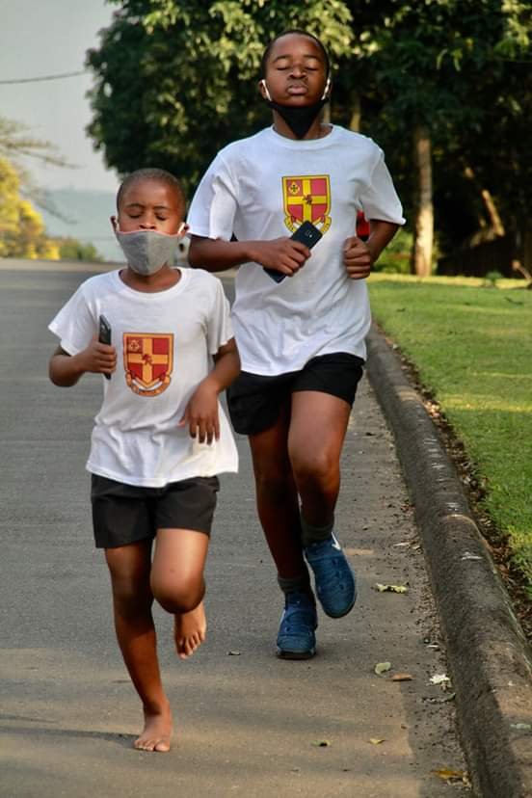 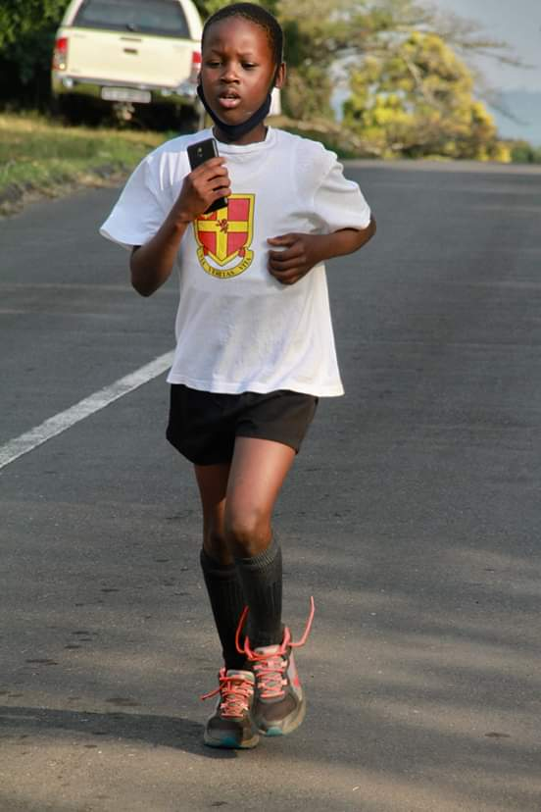

***Stay safe!*** School contact details: 035 474 2516

In the service of our children If the TELKOM line is not working please use 074 808 0698

**Mr A.M. Stuart JOHN WESLEY SCHOOL**

PRINCIPAL **FNB Account No 5219 1085 079**

**…………………………………………………………………………………………………………………………………………………………………**

**JOHN WESLEY SCHOOL ESHOWE NEWSLETTER Tuesday 14 July 2020 REPLY SLIP**

I, the parent of __________________________________________________________________________ in Grade ______

have received and read the newsletter for Tuesday 14 July 2020.

Signed: __________________________________________________Date: ________________________________________

Cell number/s:_________________________________________________________________________________________