**JOHN WESLEY SCHOOL ESHOWE**

**SPECIAL LOCKDOWN NEWSLETTER 4**

**Monday 15 June 2020**

Dear Parents

**“*Give all your worries and cares to God, for He cares about you.”* 1 Peter 5:7**

**GRADE 6 & 7**

The Grade 6 & 7 classes are back and enjoying school. It is so good to see their smiling eyes!

**GRADE 1**

The Grade 1 class will return this Wed 17 June. Masks must be worn. They will start at 07:15 and end at 12:30. Mrs Basson will be waiting to screen them before they enter the classroom. The Grade 1 class will be using the Grade 1 and Grade 3 classrooms for lessons. Mrs Waiswa will assist in monitoring.

**RETURN OF OTHER CLASSES**

The Department of Education has approved our dates of return as follows:

GRADE 2 Monday 22 June: times 7:30 to 12:45 (Friday close at 12:30)

GRADE 3 Monday 29 June: times 7:15 to 13:00 (Friday close at 12:15)

GRADE 4 Monday 6 July: times 7:15 to 14:15 (Friday close at 12:15)

GRADE R “ “ “ : times 7:30 to 12:45 (Friday close at 12:30)

GRADE 5 Monday 13 July: times 7:30 to 14:30 (Friday close at 12:30)

**COUNSELLING**

If any person needs counselling during this unsettled time, there are a number of people trained to assist us (some of the following people do charge a fee)

* Rev Sakhi Ciliza (Minister at Eshowe Methodist) 078 508 0860 [edmundciliza@gmail.com](mailto:edmundciliza@gmail.com)
* Ms Corli Viljoen (Registered counsellor) 078 385 8903 [renewft.1@gmail.com](mailto:renewft.1@gmail.com)
* Ms Robin Wagenaar (Psychologist in training) 081 565 0564 [robinwagenaar@hotmail.com](mailto:robinwagenaar@hotmail.com)
* Ms Mandisa Majola (Psychologist – rooms near Steers) 067 145 3743 [ndikamajola@gmail.com](mailto:ndikamajola@gmail.com)
* Ms Shelley Hall (Psychologist at Dr Brits rooms) 063 055 2172 [shelleykimhall@icloud.com](mailto:shelleykimhall@icloud.com)

**FINANCES**

Thank you to those who have paid fees, however, a number of parents are still behind in payments. If you have lost your job or salary because of COVID 19, **please collect an application from the office to inform us**. We are pleased to announce that we have received our government subsidy for this term.

**COVID 19 EMERGENCY NUMBERS FOR THE DEPARTMENT OF HEALTH**

0800 029 999 or 0800 111 132 or WhatsApp 060 012 3456

Healthcheck: *134*832# (free) Government website [www.sacoronavirus.co.za](http://www.sacoronavirus.co.za)

**WORKPACK COLLECTION**

Today WORKPACKS are being collected:

Grade R – 08:00 to 09:30; and **Wednesday 17 June**

Grade 2 – 11:00 to 12:30; Grade 4 – 08:00 to 09:30

Grade 3 – 12:30 to 14:00 Grade 5 – 09:30 to 11:00

If you cannot be here at the time allocated, please come at any time during the day.

Next WORKPACKS will only be for **Gr R, 4 and 5**. Collection will be on Monday **29 June** from 08:00 to 10:30

**SCHOOL WEBSITE**

Special thanks to Miss Beukes who has built a new website for our school. The link is: <https://jwseshowe.co.za/>

Please have a look – the website also contains newsletters.

**DESKS**

We are needing to borrow or buy 30 single junior primary desks. If anyone can help, please let us know.

**MERIT CERTIFICATES**

The following children have gained their **YELLOW** CERTIFICATE (150 merit points) since last assembly. If you are not at school, we will send your certificate with your workpack. CONGRATULATIONS TO:

Grade 2 **Banele Ngidi**, **Melokuhle Nzuza** and **Aphile Msebeni**

Grade 4 **Muzi Biyela, Abongile Gumede, Sphesihle Khambule, Lwandile Madondo, Ndalo Mchunu,**

**Londeka Mkhize, Lwazi Ngema** and **Aneliswa Sishi**.

Grade 7 **Zakhona Mpanza, Minenhle Mtetwa, Thubelihle Ntuli, Wandile Gumbi, Nomfundo**

**Gumede, Lindo Khumalo, Samkele Dlamini** and **Aphiwe Makhathini**.

One child from Grade 5 has achieved his **RED** CERTIFICATE (300 merit points). Special CONGRATULATIONS to **Sandla Mpungose**!

**WAITING FOR ALL OUR LEARNERS**

The garage wall has been painted with COVID 19 prevention messages by our very artistic teachers:

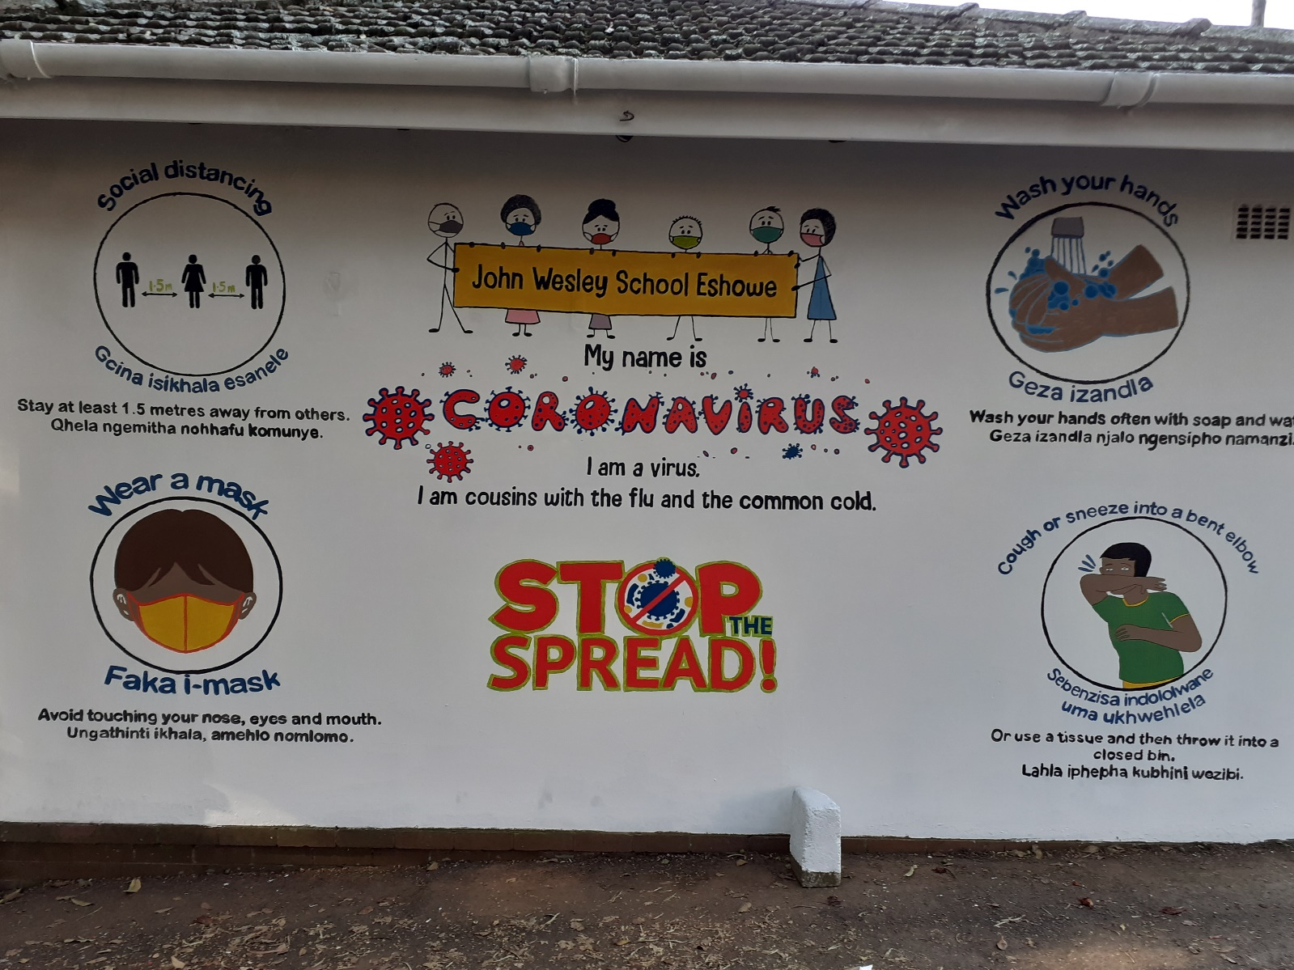

**YOUTH DAY**

Tomorrow (Tuesday 16 June) is Youth Day. School will be closed for the public holiday.

***Stay safe!*** School contact details: 035 474 2516

In the service of our children If the TELKOM line is not working please use 074 808 0698

**Mr A.M. Stuart JOHN WESLEY SCHOOL**

PRINCIPAL **FNB Account No 5219 1085 079**