**JOHN WESLEY SCHOOL ESHOWE**

**SPECIAL LOCKDOWN NEWSLETTER 3**

**Tuesday 9 June 2020**

Dear Parents

**“*God has not given us a spirit of fear, but of power and of love and of a sound mind.”* 2 Timothy 1: 7**

**GRADE 7**

Today we have **all** our Grade 7’s in class! They are enjoying their spacious classroom and working hard.

**GRADE 6**

The Grade 6 class will return to school tomorrow (Wed 10 June). Masks must be worn to school. They will start at 07:15 and end at 14:15. Please arrange transport accordingly. They will not have break at the same time as Grade 7.

**GRADE 1**

The Grade 1 class will return next Wed 17 June. Masks must be worn. They will start at 07:15 and end at 12:30. Mrs Basson will be waiting to screen them before they enter the classroom. The Grade 1 class will be using the Grade 1 and Grade 3 classrooms for lessons. Mrs Waiswa will assist in monitoring.

**COUNSELLING**

If any person needs counselling during this unsettled time, there are a number of people trained to assist us (some of the following people do charge a fee)

* Rev Sakhi Ciliza (Minister at Eshowe Methodist) 078 508 0860 [edmundciliza@gmail.com](mailto:edmundciliza@gmail.com)
* Ms Corli Viljoen (Registered counsellor) 078 385 8903 [renewft.1@gmail.com](mailto:renewft.1@gmail.com)
* Ms Robin Wagenaar (Psychologist in training) 081 565 0564 [robinwagenaar@hotmail.com](mailto:robinwagenaar@hotmail.com)
* Ms Mandisa Majola (Psychologist – rooms near Steers) 067 145 3743 [ndikamajola@gmail.com](mailto:ndikamajola@gmail.com)
* Ms Shelley Hall (Psychologist at Dr Brits rooms) 063 055 2172 [shelleykimhall@icloud.com](mailto:shelleykimhall@icloud.com)

**FINANCES**

Thank you to those who have paid fees, however, a number of parents are still behind in payments. Please keep up to date. We are doing our very best to make sure that your child completes this year successfully. If you have lost your job or your salary because of COVID 19, **please collect an application from the office to inform us** about this. We are pleased to announce that we have received our government subsidy for this term.

**COVID 19 EMERGENCY NUMBERS FOR THE DEPARTMENT OF HEALTH**

0800 029 999 or 0800 111 132 or WhatsApp 060 012 3456

Healthcheck: *134*832# (free) Government website [www.sacoronavirus.co.za](http://www.sacoronavirus.co.za)

**WORKPACK COLLECTION**

Next WORKPACK collection will be on **Monday 15 June**

Grade R – 08:00 to 09:30; and **Wednesday 17 June**

Grade 2 – 11:00 to 12:30; Grade 4 – 08:00 to 09:30

Grade 3 – 12:30 to 14:00 Grade 5 – 09:30 to 11:00

If you cannot be here at the time allocated, please come at any time during that day. Please bring this completed WORKPACK so that the teacher can mark it. Remember that you are saving on transport money while on LOCKDOWN, so please spend that money on data for connection to WhatsApp etc.

**SCHOOL WEBSITE**

Special thanks to Miss Beukes who has built a new website for our school. The link is: <https://jwseshowe.co.za/>

Please have a look – the website also contains newsletters.

**WAITING FOR ALL OUR LEARNERS**

The teachers are waiting patiently for all their learners to return. Some teachers are painting the garage wall with COVID 19 prevention messages:

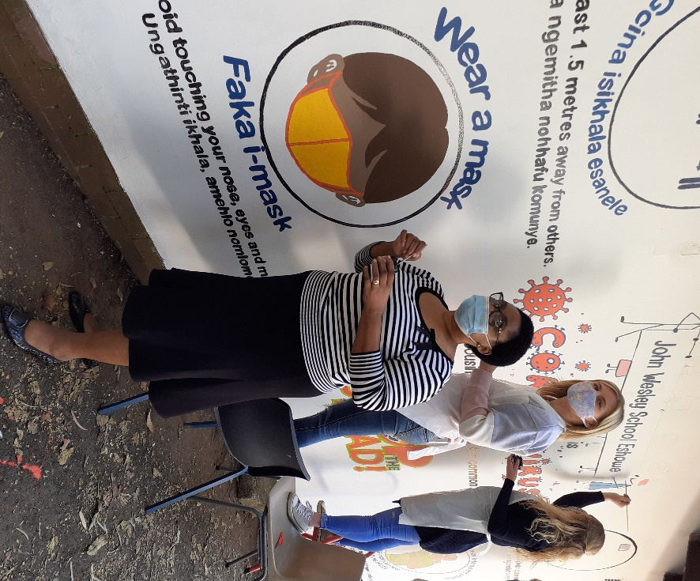

The Grade 7’s are playing a social distancing game:

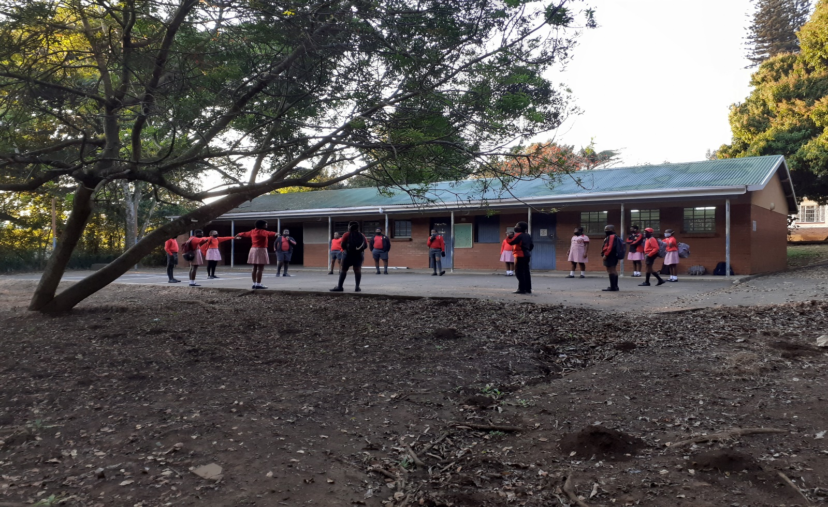

***Stay safe!*** School contact details: 035 474 2516

In the service of our children If the TELKOM line is not working please use 074 808 0698

**Mr A.M. Stuart JOHN WESLEY SCHOOL**

PRINCIPAL **FNB Account No 5219 1085 079**